July 2, 2024


Letter of Recommendation

To UWE Bristol

Dear Admissions Committee,

I Roshini V, Director of educ kshetra am writing this letter to highly recommend Mr.Jayesh Jayanand for his admission to Master’s degree at your esteemed University.
Jayesh Jayanand was associated with our company for the past one year as a Senior Trainer in advanced technologies, His interactive training methods and innovative approach have consistently received positive feedback from participants. Furthermore, Jayesh Jayanand is an extremely organized and self-motivated individual. His most significant strength is his commitment to professional growth and development. He continuously seeks opportunities to expand his knowledge and stay updated with the latest trends and best practices in training and development.
I strongly recommend Jayesh Jayanand and am confident that he will bring the same level of dedication, expertise, and enthusiasm to your University. His passion for education and commitment to excellence make him an ideal candidate for your program.
Please do not hesitate to contact me if you require any further information. I wholeheartedly endorse his candidature and look forward to seeing his future accomplishments.
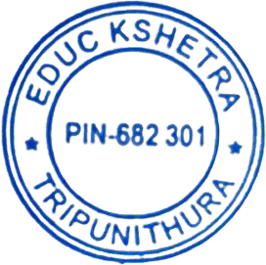
Yours Sincerely, For educ kshetra

Roshini V Director

Branch : SBC 2, First Floor, Thapasya Building, Infopark, Kochi 682042 Kerala, India Email : roshiniv@educkshetra.com. Web address : www.educkshetra.com







